TO**:** Anoka County Board of Commissioners and Staff

FROM: Anoka County Election Integrity Team (ACEIT)

DATE: March 28, 2023

SUBJECT**:** Voter Registration Rolls_If Not ERIC

-----------------------------------------------------------------------------------------------------------------------------------------------------------

**Introduction:**

* In the past 15 months seven states have left, or are leaving, ERIC because it has been proven that ERIC is not performing to the level that is needed to support the maintenance of an accurate list of who is eligible to vote.
* The question then arises, “How do states which don’t use ERIC ensure Voter Roll accuracy?”

**Considerations:**

* Alternatives have always existed, and are now expanding, as people are becoming aware of the shortcomings with ERIC, e.g.
  + Perform the cross-check work “in house.” This is done in many states using federal files, such as the NCOA, as well as state agency files, AND potentially include the use of, if deemed to be “value add,” the new Public Interest Legal Foundation resource.

*The Public Interest Legal Foundation (PILF), a national, non-profit, law firm dedicated to election integrity, announced the launch of the website on Feb. 27. The new interactive website database is now available free to individual citizens and election reform groups across the country to help in the fight to get all states to obey a federal election law mandating regular voter roll maintenance.*

* + Engage with Omega4America to have their organization perform the cross-checks for anomaly reports (similar to ERIC).
    - Their patented fractal technology is more advanced than what the ERIC system has to offer; it is capable of processing every voter roll, in every state, on multiple dates at silicon speed.
    - Omega4America currently has teams operating in one or more counties in 13 states.
    - Per Open Letter to SOS Raffensperger:

*The Raffensperger Challenge is as follows: the Omega team will engage with any state where an election integrity team invites us – we will take their voter roll after it is “cleaned” by ERIC.*

*We will ingest the property tax rolls for that state – a county or two – to demonstrate whether the ERIC-cleaned voter rolls reconcile with the property tax rolls.*

* According to the National Conference of State Legislatures*, Voter Registration List Maintenance is managed by counties and states by obtaining local and state records reflecting potential changes. This is true whether they contract with ERIC or do not.
* All of these alternatives **STILL require trusted internal policies to:** 
  + **Assertively investigate the anomalies** identified and communicate with those on the anomaly lists to validate the appropriate action.
  + **Collaborate with other counties and states** to ensure accurate and timely updates of the Rolls.
* It is not as time-consuming to do the electronic cross-checks as it is to do the work Anoka County is already doing (in previous bullet); therefore, it would seem that this would not be an overwhelming responsibility to add to the Anoka County Elections & Registration Team.

**Conclusions/Requests:**

* The County is responsible for the accuracy of the county’s data and the county’s election results. We have identified Voter Registration Roll accuracy issues in Anoka County.
* The true “heavy lifting” involved in Voter Registration Roll accuracy is the work to communicate with people to validate potential changes AND to communicate/collaborate with other counties and states to validate moves. This is already something for which Anoka County is responsible. Perhaps a review of the procedures and execution in these areas would be helpful.
* We are requesting that by 05/30/2023 Anoka County data be submitted to Omega4America to be run through recommended cross-checks they perform using their Fractal Technology to determine if additional anomalies are identified. This will then provide key information in determining if there are Voter Registration Roll accuracy issues, and whether it would be wise to have an ongoing contract with Omega4America for identification of data anomalies needed to clean the Rolls.

**Links/Resources:**

[Iowa & Ohio Signaling Exit of ERIC](https://www.courthousenews.com/state-voter-fraud-system-fractures-as-republicans-opt-out/) News article regarding the 6th & 7th states leaving ERIC

<https://publicinterestlegal.org> PILF-Public Interest Legal Foundation website of state Voter Roll errors

[Fractal Finds Many More Errors Than ERIC](https://www.thegatewaypundit.com/2023/02/869268/) News article to Open Letter from Jay Valentine to ERIC Executive (2/25/2023)

[Fractal Programming Election Integrity System (FPEIS)](https://www.thegatewaypundit.com/2022/03/voter-registration-anomalies-exposed-fractal-voter-registry-fpeis-live/) News article on what this database is and how it works/looks

[Open Letter to Georgia SOS Raffensperger](https://www.thegatewaypundit.com/2023/03/epic-project-omega-sends-letter-to-georgias-secretary-of-state-and-announces-the-raffensperger-challenge-in-honor-of-his-defense-of-the-eric-voter-roll-system/) News article and link to Open Letter from Valentine to Raffensperger (3/16/2023)

<https://www.ncsl.org/elections-and-campaigns/voter-registration-list-maintenance> *Listing by state of files utilized

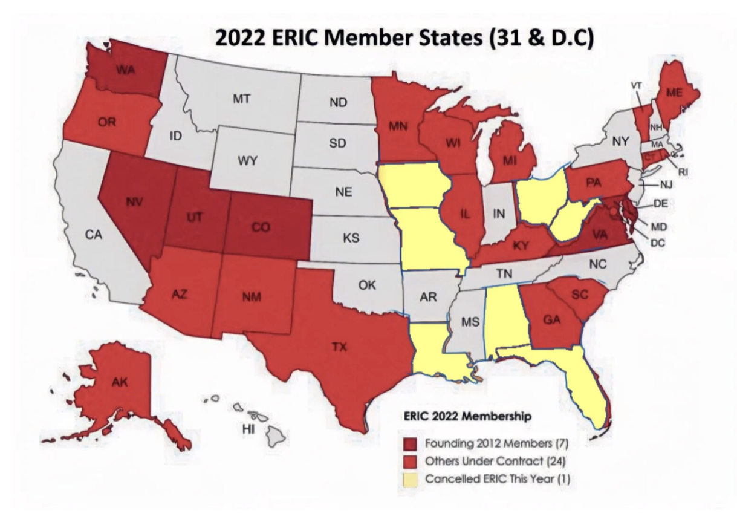

February 25, 2023 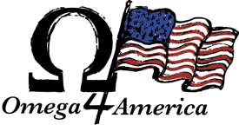

Mr. Shane Hamlin

Executive Director

ERIC

1201 Connecticut Ave NW

Washington, DC. 20036

**Re: Election Integrity Database – Minimum Viable Product – MVP – Open Letter**

Dear Mr. Hamlin,

My name is Jay Valentine and I direct the Fractal Technology Software Team at Project Omega.

This letter is to advise you that using our Fractal Technology software we processed the voter rolls for multiple states that use the ERIC system, and the results demonstrate ERIC is failing to clean voter rolls, and the number of fake people and fake addresses in the voter rolls is large enough to change election outcomes in every state we examined.

**Our Background**

We built artificial intelligence applications for decades, far before AI became trendy.

Members of our team solved massive fraud and security problems that plagued companies and industries for years where no previous solutions were effective or available.

* **eBay** - successfully eliminated an entire generation of cyber fraud
* **State Farm, USAA, GEICO** - identified and stopped sophisticated multi-million-dollar auto insurance fraud rings
* **TSA No-Fly List -** developed the underlying name-matching technology to screen out terrorists and other corrupt actors

We have the expertise to find people hidden, accidently or deliberately in complex data.

**Applying Our Technology to Voter Rolls**

In April, 2021, Wisconsin citizens invited the Fractal team to apply our disruptive technology, Fractal Programming, to examine Wisconsin election roll and assess its overall accuracy. What we discovered led us to look beyond one state’s records to those of many others.

In states running ERIC, we regularly found voters registered in jails, hotels, cognitive care facilities, RV Parks, churches, UPS Boxes, libraries, skating rinks, under-construction-buildings and scores of other properties which cannot legally house a registered voter.

By way of example, in just about every state we examined, there were many – often hundreds – of voters older than Abraham Lincoln registered, active and voting. Even a cursory review, with simple technology should have quickly flagged them.

We were equally concerned as to how there could be people registered and active at a college fraternity house – who were over 50 years old, some over 105 years old. A simple examination using a Microsoft Excel spreadsheet would have identified these screaming “anomalies.”

We found the ERIC system does not appear to clean voter rolls in a manner consistent with what current technology can accomplish.

**Great Concern for Election Integrity**

Tens of thousands of phantom voters remain on the rolls in every state we examined – in some states there are hundreds of thousands. The clear message is that there are enough “phantom” names and addresses in voter rolls of states using the ERIC system to impact election outcomes.

The numbers of “phantom” voters embedded within voter rolls ought to be a huge concern to ERIC’s management team and should alarm every state that uses the ERIC system.

**Additional Findings**

**Registration Manipulation in Voter Rolls**

Using Fractal analysis, aided by our advanced artificial intelligence (AI) address matching, we found actual movement in data rolls that should concern citizens.

A few months before elections, we observed a steady increase of new voter registrations which retreat and disappear right after the election. This critical information should have been reported to states where key counties in their states saw previous registrations erased and removed right after elections. We have no indication that such notification was given.

**Zip Code Manipulation in Voter Rolls**

We discovered election commission changes to zip codes of a county’s citizens around the time mail in ballots are printed and mailed, then they are changed back after the mailing. These ballots become undeliverable and “free floating” and subject to corruption.

**Undeliverable Ballot Database**

This led us to develop an innovation - The UnDeliverable Ballot Database. This database profiles each physical location in any state using personal property tax records. Addresses are run through an AI Address Engine, then cross-checked with the equivalent address in the voter registration files.

Thus, with complete fidelity, one can determine where an election commission intends to send a mail-in ballot but is very unlikely to find its recipient.

**Real Life Application**

In an expert witness report for a southwestern state governor’s race, we showed how the county election commission made thousands of changes to their voter rolls AFTER the legal date to do so. Every such change is illegal. Many of those ballots were ineligible to be cast.

The number of such changes, in only one county, were enough to impact the outcome of that election.

ERIC should have discovered this and reported it immediately to election authorities. But as ERIC does not appear to be able to perform real time voter roll analysis, such election interference went unreported.

**Fractal Technology**

Fractal technology is far more advanced than the methods ERIC appears to use.

Our record count is far larger than that run by ERIC because we make transparent the “movement” within election rolls. We take “snapshots” of every voter roll multiple times across multiple dates. We compare every record, against every other record, in every time series – and identify a change as subtle as a missed comma. We can identify every change made by elected officials that could impact an election and make them visible to citizens.

In some states we have 30 or more copies of their voter roll from different dates. This comparison enables us to show users how data changes over time. Those changes – over time – in the same voter roll opened a new vista in finding anomalies requiring attention.

This is pretty valuable information to voter integrity teams – as well as to candidates.

With Fractal technology, we can process every voter roll, in every state, on multiple dates, on a few small computers, with every query delivered at silicon speed – to a citizen’s or elected official’s phone.

We believe this should now be the absolute **minimum standard** for every state.

**A New Level of Transparency**

As noted, **personal property tax records** are available on-line from most counties for citizens to examine, challenge, rectify. Citizens have confidence they are being taxed in a manner consistent with their neighbors – because that data is transparent.

There is no reason **election rolls** should not have the same level of transparency – leading to accuracy and confidence. They should no longer remain opaque, with no ability to see who is added or removed. Citizens and/or their elected officials as each state designates – need full transparency.

**The Exponential Growth of Our Services**

We currently run the voter rolls for about 12 states, with about 1.7 billion records. Another 20 state voter integrity organizations made rolls available – we expect to add them 2023.

The UnDeliverable Ballot Database is now built for several states and being rolled out to additional states.

**What Citizens Want**

In 2021 and 2022, we learned citizens in every state desperately want clean voter rolls. Polls continue to show citizens do not believe voter rolls are clean – they actually believe the opposite is true. Our analysis proves, with no room for doubt, every state’s voter roll we processed does not meet the minimum standard for what is required of a public corporation.

Comparing state voter rolls to county rolls shows they often do not reconcile – by wide margins. And comparing voter rolls with personal property rolls – considered by many as the most pristine government database – shows they do not reconcile as well.

There cannot be two sets of government records – property tax rolls and voter registration rolls that do NOT AGREE! It should be… inconceivable… yet that appears to be the case.

**Minimum Viable Product**

A Minimum Viable Product (MVP) is needed – one every state can adopt to maintain accurate voter records, reconcile state and county rolls, and help registrars keep voter rolls clean.

I take this opportunity to share with you what the MVP should be. In the attached document, I present the absolute minimum we believe ERIC should deliver to meet its charter – cleaning voter rolls.

**Next Steps**

I invite you and your team to add to this list and together we can offer our great country better, multiple alternatives to clean voter rolls, make all changes transparent, real time, to citizens, on their phone, at silicon speed and with surprising economy.

We are contacting the Governor, Attorney General and Secretary of State for all ERIC states to share these recommended Minimum Viable Product requirements.

We will also make our findings available to these executives of what we are seeing with current ERIC-managed voter rolls – in live demonstrations.

By this letter, we have introduced ourselves. We look forward to meeting you in person soon.

Best regards,

Jay Valentine

Project Omega

www.Omega4America.com

Copies:

Governor of all ERIC users

Attorney General of all ERIC users

Secretary of State of all ERIC users

Mr. George Soros, Open Society Foundation

Chairman Republican National Committee

Chairman Democrat National Committee