**MEMORANDUM**

TO: ANOKA COUNTY ELECTION INTEGRITY TEAM

FROM: POLL PAD USE SUB-TEAM (Amy, Bob, Joe, Lori, Scott)

DATE: DECEMBER 9, 2024

SUBJECT: POLL PAD USE LEGAL MEMO **(DRAFT 12/07/2024)**

**_________________________________________________________________________**

**TABLE OF CONTENTS**

**SECTION PAGE**

**I. INTRODUCTION 2**

**A. BACKGROUND FACTS**

**B. QUESTIONS**

**C. ANSWERS**

**II. FACT FINDING 4 A. 2018 AGREEMENTS**

**B. CITY OF OAK GROVE CASE**

**C. COUNTY MEMORANDUM**

**D. CITY OF RAMSEY CASE**

**E. STATUTORY STATUS OF ANOKA COUNTY**

**F. MINNESOTA ELECTRONIC ROSTER PRACTICES**

**G. RELATED FACTS**

**III. DISCUSSION AND FINDING 19 A. ANOKA COUNTY CASE IN BRIEF**

**B. THE ANOKA COUNTY CASE**

**C. GRAPHIC ILLUSTRATIONS**

**IV. CONCLUSION 22**

**V. EXHIBIT A 23-31**

**VI. EXHIBITS B-V Separate Document**

**I. INTRODUCTION**

**A. BACKGROUND FACTS**

1. In 2014 the Minnesota State legislature authorized optional use of electronic roster systems or epollbooks (aka poll pads) (Exhibit A-3 and Exhibit B).

2. On July 17 and July 27, 2017 Anoka County discussed an application for funding to purchase epollbooks but it was uncertain how many precincts would be included. A staff report stated: “we have heard enthusiastic support from our larger cities who view pollbooks as very beneficial to their operations” but “our smaller jurisdictions may not share the same enthusiasm for the new technology and may want to wait until later year to implement” (Exhibit C).

This statement implies an advice and consent decision-making process whereby municipalities have the authority to decide if they will use poll pads or not, or that the County has the power to impose use but would be willing to honor the choice of the municipalities. Furthermore, this implies that using poll pads in some precincts and not in other precincts would be a workable plan acceptable to the County as is the case in 18 other counties in the State of Minnesota.

3. On October 16, 2017 the Anoka County Property Records and Taxation Committee recommended approved a grant application to cover part of the purchase of epollbooks for use “in all precincts” (EXHIBIT D).

4. On October 24, 2017 the Anoka County Board approved a resolution to seek State funds toward purchase of “electronic rosters to be used in all precincts in the county with planned implementation at the 2018 State Primary Election” (Exhibit E).

5. On March 12/27,2018 the Anoka County Board approved purchase of electronic rosters from KNOWiNK, LLC (EXHIBITS F & G).

6. On May 2, 2018 Anoka County informed the Secretary of State of intent to use KNOWiNK Poll Pad hardware and software in all of its precincts in its 2018 state primary and general elections (EXHIBIT H).

7. In July of 2018, 21 agreements between Anoka County and all municipalities for use of the epollbooks in all precincts in Anoka County were created and signed by the County Administrator, Assistant County Attorney and various representatives from the 21 municipalities (EXHIBIT I).

8. In September 21/28, 2021 Anoka County and 21 municipalities and nine school districts entered into amended Joint Powers Agreement for deployment, use and cost sharing for the vote tabulation equipment purchased earlier from Election Systems & Software Inc. (ES&S) in 2013. These agreements have no connect with the electronic roster use agreements (EXHIBIT J).

9.None of these 21 agreements were approved by a formal vote by the Anoka County Board (EXHIBITS N & O).

10. Research to date indicates that only one municipality (City of Oak Grove) voted to approve them in June of 2018 (EXHIBIT I).

11. In 2024 several Anoka County municipalities have indicated their desire to terminate use of the epollbooks by terminating their agreement for use with Anoka County. Two municipalities have passed resolutions terminating their agreements including the City of Oak Grove on September 30, 2024 (EXHIBIT L) and the City of Ramsey on November 12, 2024 (EXHIBIT R).

12. Anoka County officials have made the claim that the head election official in the County (defined as the County Auditor) has unilateral authority to mandate use of epollbooks in any or all precincts within the County (EXHIBIT P)

13. Some municipalities question this claim and thus a legal question arises.

**B. QUESTION(S)**

1. Do Minnesota county auditors have the statutory authority to mandate use of electronic roster systems (aka electronic pollbooks or poll pads) in any or all precincts within their county without the approval of the governing bodies of the municipalities (cities and townships) involved?

2. May municipalities independently decide if they will use electronic rosters (aka epollbooks or poll pads) in any or all of their precincts?

**C. ANSWERS**

1. No. Minnesota county auditors must promulgate rules for deployment and use of electronic roster systems in any or all precincts within their county and said rules must be authorized by the governing bodies of the municipalities involved.

2. Yes. Municipalities in Anoka County may decide if they will use electronic roster systems (poll pads) based upon statutory provisions that require municipal approval of County rules (201.221, subd. 4), municipal option to revoke precincts designated for poll pad use (201.225, subd. 6), and, in Anoka County, municipal option to terminate 2018 agreements for use (Section 7).

3. Furthermore, the discharge of statutory duties and exercise of any statutory discretionary authority of county auditor is born by the Anoka County Board of Commissioners and then may be delegated to an appointed official within their organization delegation (383E.04).

**II. FACT FINDING**

**A. 2018 AGREEMENTS.** In 2018 identical agreements for use of electronic roster system (poll pads) were created and signed by officials from Anoka County and all 21 municipalities in Anoka County. These agreement number are C0006579 through C0006599.

1. These is no record of formal approval by the Anoka County Board of Commissioners including:

a) No publicly posted meeting agenda

b) No publicly posted staff report

c) No publicly posted agreement documents

d) No public discussion held

e) No public vote taken

f) No publicly posted meeting minutes

2. There is no record of formal approval by the governing bodies of 20 of the 21 municipalities in the County (except for the City of Oak Grove) including:

a) No publicly posted meeting agenda

b) No publicly posted staff report

c) No publicly posted agreement documents

d) No public discussion held

e) No public vote taken

f) No publicly posted meeting minutes

3. A Data Practices request produced no evidence of County approval (EXHIBIT N).

4. Another request produced no evidence of County approval (EXHIBIT O).

5. Because the Anoka County Board of Commissioners never approved these agreements, there was no delegation of authority to the head election official (aka County Auditor) authorizing deployment, supervision and use of the electronic roster system.

6. Because all but one municipality never approved the agreement there was no approval of or acceptance of any delegated authority to the head election official for deployment, supervision and use of the electronic roster system by those municipalities.

7. Voting to buy the poll pads is not the same thing as voting to approve their use with 21 municipalities.  These would be two different actions.  However, it does show intend to do so, intent to delegate tasks to staff and intent to use county-wide due to the numbers.  Nonetheless, showing intent is not the same as actually authorizing it.  Furthermore, the specific agreement terms including term (June 18, 2018 until cancellation), licensing, equipment ownership, liabilities, costs (shared or not), equipment handling, insurance and termination (after 7-day notice) were not identified or known at the time of purchase and should have been acted upon after purchase.  Therefore, the 2018 agreements should have been formally approved.

8. The KNOWiNK purchase vote itself did not reference the cities other than implication via the number of poll pads to be purchased.  However, the October 24, 2017 vote to seek a grant includes intent to use them "in all precincts in the county."  This is the first time we find this.

9. The claim that municipalities may terminate use and not use them in the future does not depend upon the fact that the County did not vote on the 2018 agreements.  There are other statutory and agreement reasons why municipalities have choice.  But the non-vote issue raises questions about whether the poll pads were legally authorized and deployed as well as lack of transparency in the decision-making process.  It is very possible that few, if any, of the city attorneys ever saw these agreements.

10. A County Election Manager does not have the authority to create a new agreement with precincts without municipal approval - Why?

* 1. Municipalities have jurisdiction over their precincts; the county can't skip the municipalities governing authority unless the municipalities gave the County the authority as stated in the 2018 Agreements.
  2. The ePollBook agreements signed by the municipalities were not Joint Powers Agreements and did not delegate the authority to use ePollBooks back to the County.
  3. MN Statute 201.221, subd 4 clearly states that if the county auditor adopts new rules for municipalities or SOS, not precincts, then a new agreement and plan with the duties has to get approval from that municipality or SOS.
  4. Even if the ePollBook agreements we have seen gave the Anoka County the authority, once the agreement is terminated, their authority is also terminated.

11. The delegation to the Anoka County Elections Manager in the Agreement is limited to the quantify or definition of the Election Equipment assigned to each Jurisdiction and to keep a record of such assignments.  The delegation of authority is not over the entire agreement.

12. Evidence so far indicates that only 1 of 21 municipalities (20 cities, 1 township) publicly discussed or voted to approve the 2018 agreements.  That one was Oak Grove.  Did any of the councilmembers or town board members in Anoka County even know what they were getting?  Did they know that their voter data would be leaving their precincts in real time?  Their voters probably did not know this either.  What if both had known?  Would they have approved poll pad use?

13. Agreement excerpts and ACEIT response:

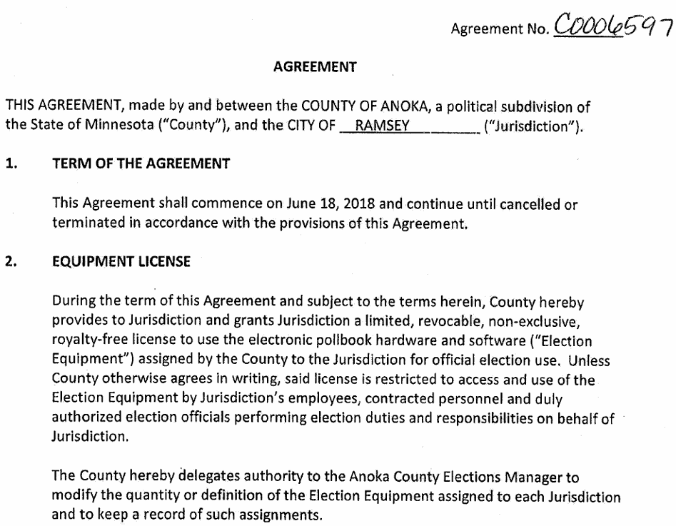

a. The agreements are between the governing bodies of Anoka County and municipalities.

b. The term began on June 18, 2018 and would “continue until cancellation or termination.”

c. The County may delegate authority to the Anoka County Elections Manager to modify the quantity or definition of the Elections Equipment subsequent to the agreement by both parties.

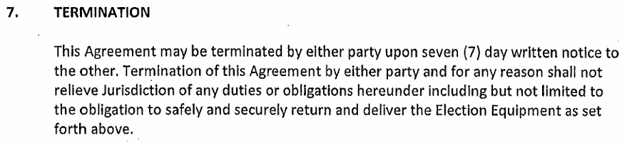

d. The agreement may be terminated by the County or each municipality.

e. The effective date of termination is just seven days after notice.

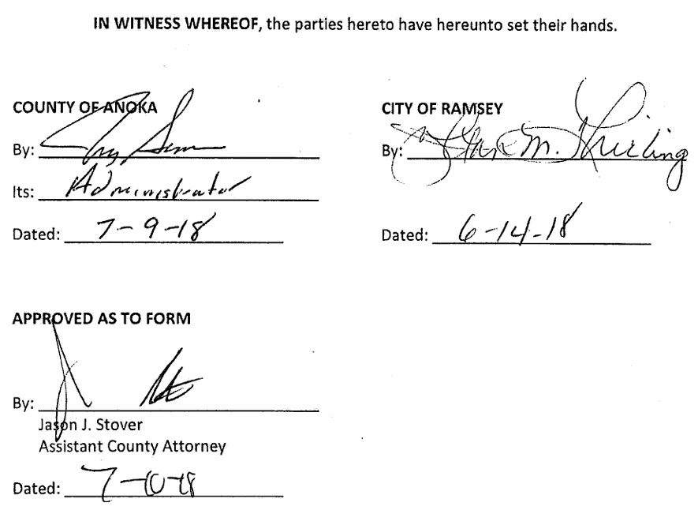

f. All 21 agreements are signed by the County Administrator and Assistant County Attorney, not by any elected officials.

g. Municipal signatories vary from administrator or city clerk, and rarely by an elected official.

h. Why were these agreements created if cancellation has no meaning or effect as Anoka County now claims? In point of fact, it appears that the 2018 Agreements are prima facie evidence that the County recognized that municipal consent was necessary in order for the County to supply and the local elected officials to use the electronic roster system (aka poll pads) in their precincts.

**B. OAK GROVE CASE**

1. The City of Oak Grove approved the agreement for use of poll pads on June 25, 2018 (EXHIBIT I).

2. The City of Oak Grove, by resolution, voted to cancel said agreement on September 30, 2024 (EXHIBIT L).

3. Election Director, Tom Hunt, informed the City by letter that the County acknowledged the termination action, requested return of the poll pads but informed the City that they must use the poll pads in the 2024 General Election (EXHIBIT M).

**C. COUNTY MEMO.** On about October 28, 2024 a memorandum was sent to the head election judges in the 21 municipalities from the Anoka County Elections Department concerning the use of electronic rosters systems (poll pads) during the 2024 general election.

1. It was not dated and the author was not identified.

2. Anoka County claims and ACEIT responses:

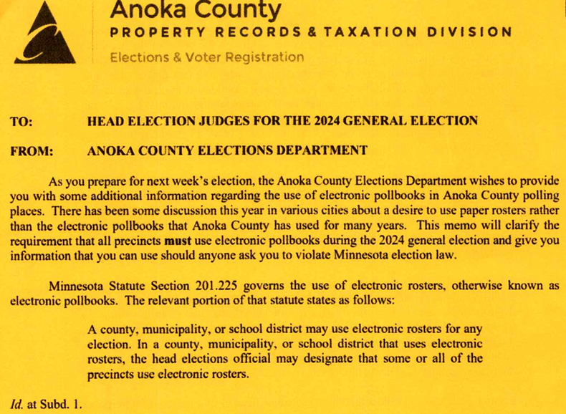

a. The first sentence of 201.225, subd. 1 equally enables county, municipality or school district to decide if they will use electronic rosters or not. It does not mandate their use by any jurisdiction.

b. The second sentence enables a county, municipality or school district that decides to use them, to then and only then, authorize their head election official to designate in which precincts they will be used. This sentence does not give any jurisdiction priority over the other.

c. The second sentence does not enable the county to impose the use of electronic rosters upon other jurisdictions.

d. No where in MS. 201.225 does it MANDATE the use of electronic rosters.

e. Finally, this statutory quote is incomplete. The rest of subd. 1 reads: *An electronic roster must comply with all of the requirements of this section. An electronic roster must include information required in section*[*201.221*](https://www.revisor.mn.gov/statutes/cite/201.221)*, subdivision 3, and any rules adopted pursuant to that section.*

f. These last two sentences not only require that an electronic roster must comply with all requirements of section 201.221, subdivision 4, but also must follow any rules adopted pursuant to this section. By extension, any rules promulgated by the County to a municipal election official must be approved by the governing body of the municipality (201.221, subd. 3) in order to be legally authorized. This provision states: *Delegation to a municipal official requires the approval of the governing body of the municipality.*

g. Further considerations include:

* 201.225, subd. 1:  there is an implied delegation of authority to head election judge from the governing bodies.  This delegation is referenced in the 2018 agreement.  In addition, neither the County nor the City of Ramsey governing bodies made any such formal approvals by vote.  Tom Hunt can verify that no County vote was taken--he is still looking for evidence.  To date there is no evidence that the City of Ramsey took a formal vote. The person who signed for the City of Ramsey was a prior city clerk named Ms. Jo Thieling who is no longer at the city.  The other signers were County Administrator Jerry Soma and Asst. County Attorney Jason Stover who most likely drafted these agreements.
* 201.225, subd. 1:  the execution of delegated authority must follow the rules referenced in 201.221, subd. 4 (which require governing body approval).
* 201.225, subd. 6:  reporting is subject to municipal/school district option for revocation (thus the reason for termination provisions of 2018 Agreement).
* 201. 221, subd. 4:  county rules require municipal governing body approval (thus the reason for the 2018 Agreement).
* What is the purpose of the termination clause in the 2018 Agreement if the County Auditor may override the governing body--city council?
* Was the 2018 agreement put in place due to the requirement for governing body (city council) approval of County rules under 201.221, subd. 4 and for authorization of delegation under 201.225, subd. 1?

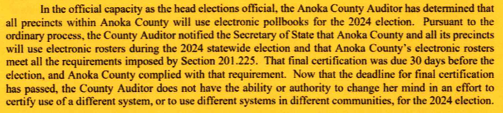

h. The question about the use of electronic rosters in the 2024 General Election is now moot because it is history.

i. The question of whether they will be used in future elections is now pertinent.

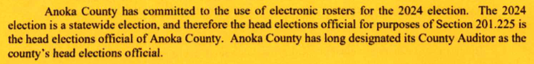

j. Stipulation: The head election official in Anoka County is the Anoka County Auditor as designated by the Anoka County Board of Commissioners and serves at their pleasure.

k. This section of the memo also implies that the authority of the County Auditor to require use of electronic rosters does not apply to local elections, specifically, those in odd years involving only municipal and school board elections.

l. This section of the memo correctly implies that no decision for use of electronic rosters for the 2026 statewide election has not been made.

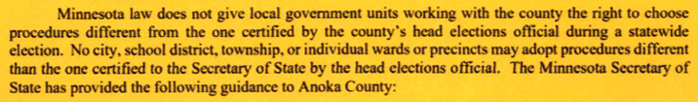

m. There is no statutory reference to support the first sentence.

n. The second sentence fails to recognize that the use of electronic rosters is subject to MS 201.221 regarding County Rules which requires promulgation of rule (procedures) by the County that are subject to municipal approval.

o. Certification to the Secretary of State for the 2024 General Election is now moot.

p. The question of whether they will be used in future elections is now pertinent.

3. Minnesota Secretary of State claims to support Anoka County Memo and ACEIT responses:

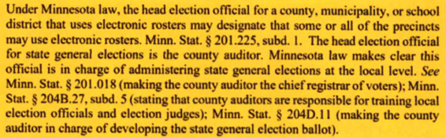

a. This section does not reference the requirement to follow 201.221 regarding County Rules as noted above.

b. None of the County Auditor authorities listed above abrogate or override the requirement to follow 201.221 regarding County Rules.

c. Counties do not unilaterally govern precincts.

d. Municipalities govern precincts in the following respects:

i. Create or modify boundaries & numbers of voting precincts (204B.14, subd.1)

ii. Designate location of polling places (204B.16, subd 1)

iii. Solicit, qualify, and appoint election judges (204B.21, Sec.2)

iv. Provide supervision/direction to election judges as delegated (204B.25 subd. 1)

v. Pay election judges (204B.31 & 206.89, subd. 9 (1)

vi. Administer election-day activities at the polls (204C)

vii. Administer hand counting of ballots and votes in each precinct (204C.19-.21)

viii. Prepare unofficial ballots if necessary (204B.30)

ix. May administer Absentee Ballot Board (203B.121 & 204B.19 to 204B.22)

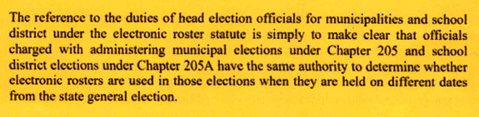

e. Stipulation: Municipalities and school districts may determine whether electronic rosters are used in their municipal elections.

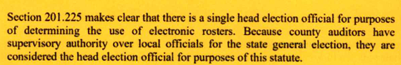

f. Where is the statutory reference to prove that “county auditors have supervisory authority over local officials for state general elections” and for this reason may mandate use of electronic rosters without municipal approval?

g. Under Minn. Stat. 383E, the county auditor in Anoka County is subordinate to the Anoka County Board of Commissioners through which all statutory authority and discretion is delegated to the county auditor. (see Section E below).

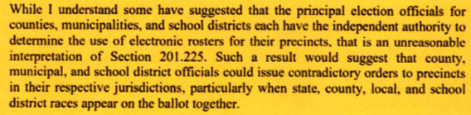h. Indeed, there may be differing desires and decisions between the county auditor and municipalities about the deployment and use of electronic rosters.

i. Such potential differences are recognized and addressed as per Minn. Stat. 201.221, subd. 4 which requires that rules promulgated by the county may not be executed without the approval of the governing body of the municipality.

j. Ostensibly, the 2018 Agreements with all 21 municipalities (although not formally approved by Anoka County and most municipalities) reflects an attempt to comply with this municipal approval requirement.

**D. CITY OF RAMSEY CASE**

1. In July of 2018 the City of Ramsey staff signed an agreement with Anoka County for use of poll pads in the city.

2. On November 12, 2024 the City of Ramsey, by resolution, voted to terminate their 2018 agreement and by another resolution voted to seek a new agreement for use of paper poll books (EXHIBIT R).

3. The City Attorney of the City of Ramsey provided his opinion (EXHIBIT S).

a. The City Attorney says the following with regard to whether a municipality may revoke use of electronic rosters in their jurisdiction: “While the context for the revocation of the notification would imply the revocation would be from the election official of the County, the language of the statute does not limit the action of revocation to the county on its face. It is possible a court could construe that language to allow a city to revoke the use of the electronic system within its own precincts.”

b. The City Attorney further recommended “that the City continue to use the electronic polling books and other electronic equipment provided by the County for this [2024 General] election cycle and address the issue of using paper polling books, if it chooses to follow this path in light of the concerns being raised, after the [2024 General] election.”

4. The City Attorney of the City of Ramsey made these comments at the Council meeting ([Ramsey City Council 11-12-2024](http://qctv.org/city_meeting/ramsey-city-council-11-12-2024/)) (EXHIBIT S):

a. The City Attorney seemed confused about whether the 2021 amended JPA covers electronic rosters or not. At one point he said the 2021 amended JPA “deals specifically with this type of equipment” and later said “except it seems these particular types of poll pads.” In fact, the 2021 JPA does not deal with poll pads. The 2021 JPAs and the 2018 electronic roster agreements are separate and unrelated agreements. Anoka County Elections Manager Tom Hunt can confirm this.

b. The City Attorney also observed that “by cancelling this particular [2018 poll pad] agreement, the County could insist…you would continue to use the pad, the electronic equipment. That wouldn’t be discretionary on the part of the City, which is why its interesting, though, that the City has the authority to get out of this contract. It would certainly open up a dialogue from the point of view of the County…So this is your opportunity to sit down with the County.”

c. The City Attorney further said that the 2018 agreement is “very, very one-sided” and “so incredibly one-sided” in favor of the County and the “awful language” relative to the City is “the second paragraph…page 3,” which says that “regardless of whatever damages may conceivably be caused by this equipment, the only thing the County will ever be responsible for is fixing it if we can’t…It’s remarkable. That is, from the City’s point of view, not a good paragraph.”

d. The City Attorney said that the authorization via signature of the City Clerk without City Council approval is not normal. Specifically, he said “as a general rule, without some kind of authorization by the Council or by the administration, that’s not normal…The specific answer is, from what I see in this record, I don’t understand what authority she had.”

**E. STATUTORY STATUS OF ANOKA COUNTY**. In 1989 Anoka County secured Minnesota legislative approval to convert the elective offices of County Auditor, County Recorder and County Treasurer from elective to appointive offices.

1. In 1989 Anoka County requested and a law was adopted to permit Anoka County to converter their offices of county auditor, county recorder and county treasurer from elected to appointed offices (EXHIBIT T).

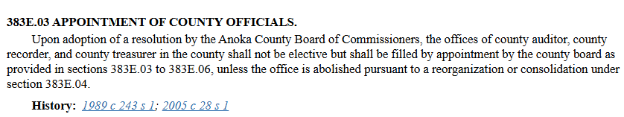

a. The statute permits Anoka County to change the offices of county auditor, county recorder and county treasurer from elected to appointed positions.

b. The County Board may appoint persons to assume the statutory duties of county auditor.

c. The advent of electronic rosters systems was in 2014, well after this conversion took place.

2. The statutory duties of the Anoka County Auditor flow through the Anoka County Board of Commissioners as per Minn. Stat. 383E.04.

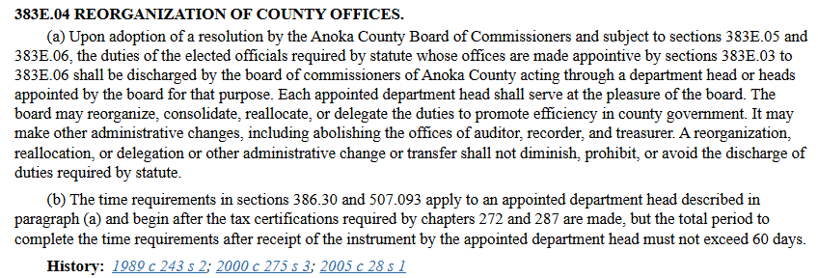

a. “The duties of the elected officials required by statute…shall be discharged by the board of commissioners of Anoka County acting through a department head or heads appointed by the board for that purpose.” This implies that the duties required by statute are the responsibility of the county board.

b. “Each appointed department head shall serve at the pleasure of the board.” This implies that the board of commissioners may set policy and direct the performance of this office within the discretion provided by statute.

c. The Anoka County Auditor is subject to 201.221-201.225 and 383E as follows:

* Subject to County Rules approval by governing body(ies) since 1987 pursuant to 201.221, subd. 4.
* Subject to County Board delegation of authority since 1989 pursuant to 383E
* Subject to cost delegation plan requirements since 1990
* Subject to electronic roster use approval by municipalities since 2014 under 201.225
* Subject to revocation option by governing bodies under 201.225, subd. 6 and 2018 Agreement termination provisions in Section 7.

d. When County auditor duties were authorized by adoption of State Statutes the Anoka County Auditor was an elected official.

e. The 1989 law authorized Anoka County to eliminate the elected county auditor and to assign auditor duties to an appointed official within their organization.

f. Specifically, under this law, the authority/accountability of the Anoka County Auditor position and function is assigned to the Anoka County Board by statute with subsequent delegation to a staff person to execute these duties as county auditor.

g. This pattern of flow and organizational structure add weight to the argument that the agreements should have been voted on by the Anoka County Board for any delegation of authority to the Anoka County Auditor as head elections official (EXHIBIT T).

**F. MINNESOTA ELECTRONIC ROSTER PRACTICES.** While any county, municipality or school district is enabled to use electronic roster systems in their precincts there is a variety of applications of the authority across the State of Minnesota.

1. The decision to use or not use electronic roster systems has been made for all 4,103 precincts in 87 counties, nearly 900 municipalities and nearly 1,800 townships. These decisions were made by some cities which are located within more than one county. Also, in 2024 there were 79 precincts located in unorganized territories in which the county is the sole election administrator (EXHIBITS U & V).

2. Public data shows that 41 counties use them in all precincts, 18 counties use them in some precincts but not others, and 28 counties do not use them in any precincts (EXHIBITS U & V).

3. What are the reasons for this varied use pattern?

4. Furthermore, there are 30 counties with appointed county auditors and 57 counties in which the county auditors are elected. See: [County Offices: Combining or Making Appointed](https://www.house.mn.gov/hrd/pubs/cntyoff.pdf).

5. Questions arise: Is there a standard practice or best practice to learn from these examples? What agreements or contracts exist among the parties? Were outcomes mandated, negotiated or done under equitable advice and consent cooperation agreements? A sample survey of jurisdictions would answer these questions.

**G. RELATED FACTS**

1. The 2013 Joint Powers Agreement (JPA), as amended in 2021, is totally unrelated to the 2018 agreements.  The definitions of election equipment in the 2021 amended JPA is for vote tabulation only (which is cost shared) and has nothing to do with voter registration equipment in the 2018 agreements (which is not cost shared).  County Elections Director Tom Hunt can confirm this fact.

2. The SOS statement and aligned Anoka County statement (ca. October 28, 2024 memo) is incomplete, inaccurate, misleading and effectively obfuscatory. It lacks full statutory context. It fails to recognize the necessary requirements of governing body(ies) approval for the use and deployment of the electronic roster system.

3. The certificate notice to SOS indicates that the form is designed for counties, municipalities or school districts which means they each have legal standing to make the use decision.

4. The initial County notification to SOS regarding electronic roster use was May 2, 2018.  That was about two months before municipal agreements in June/July were signed.  Proper due process would suggest that the letter to SOS should not have been submitted until after the formal use agreements were approved/signed.  That further proves that the 2018 agreements were based upon assumed decisions by governing bodies executed but by administrators, not formal agreements approved by governing bodies.

5. The "date" on the certification letter is September 30 and presumably done before the Oak Grove Council meeting that evening.  But when did the County actually prepared and mailed this document?

6. The revocation notice may be sent to SOS by county, municipality or school district if they made the decision to use the electronic roster.  In the case of the county-municipal "agreements," it seems that termination by any party constitutes revocation, and, in the case of these agreements, the county would be responsible for informing the SOS of changes since they sent the original notification.

7. The 2018 poll pad use agreements include delegation language which could have been necessary due to statutory requirements under MS 201.225, subd. 1.

8. "May" does not mean "must" and implies choice at precinct (municipal) level. MS 201.221 Subd 4. County Rules covers delegation of duties. This does not give Anoka County the authority to dictate the electronic roster usage because it is not a duty.

9. The State does not mandate poll pad use in any of the 4,103 precincts in the State.  How may a county claim to have powers the State itself does not claim? How may an Anoka County have appointed official hold authority over the wishes of the municipal governing bodies?

10. Adopted of Chapter 201 pre-dates the advent of electronic rosters.  That legislative history can be tracked by clicking on the links below each chapter which shows the history of amendment.  Paper was the norm; electronics were added as an option. In fact, paper poll books must be provided at each precinct as an emergency backup to the electronic roster equipment which states: “Each precinct using electronic rosters shall have a paper backup system approved by the secretary of state present at the polling place to use in the event that the election judges are unable to use the electronic roster” (201.225, subd. 5b) (EXHIBIT A-3).

12. MS 201.225 Subd 5. Election Day (a) states that Precincts may use electronic rosters. MS 201.221 Rules Subd 3. Procedures for polling place rosters states that the SOS shall prescribe the form of paper polling place rosters. The rest of the subdivision is unclear as it starts using the term polling place roster but doesn't dictate if that is paper or electronic.

**III. DISCUSSION AND FINDINGS**

**A. ANOKA COUNTY POLL PAD CASE IN BRIEF**

1. ARE ELECTRONIC ROSTER SYSTEMS (POLL PADS) MANDATED BY STATE STATUTE ANYWHERE IN MINNESOTA? NO

2. DO COUNTIES HAVE AUTHORITY TO MANDATE THEIR USE IN THEIR COUNTY WITHOUT MUNICIPAL APPROVAL? NO

3. MAY MUNICIPALITIES TERMINATE AGREEMENTS FOR USE IN THEIR JURISDICTIONS? YES

**B. THE ANOKA COUNTY CASE**

1. The 2018 agreements between Anoka County and municipalities have a termination provision which may be acted upon by either party via a seven-day written notice.
2. The authority delegated to the “head election official” terminates when the agreement terminates upon action by either agreeing party.
3. Delegated authority flows from superior to subordinate. Subordinate does not have power to retain delegated authority if superiors remove delegation by terminating the agreement.
4. The delegated authority terminates at the same time when the agreement terminates. The termination provision supersedes any delegated authority—it cancels it.
5. The agreeing parties or governing bodies are superior to the subordinate “head elections official.”
6. MS 201.225 identifies county, municipality and school district as equal entities which may decide to use the electronic roster system (poll pads).
7. If any governing body decisions to use them, then they may delegate the authority to deploy them in precincts to their “head elections official.”
8. “Head elections official” in Anoka County is the County Auditor; head elections official in municipalities is the city clerk.
9. In July of 2017 when the County was considering using an electronic roster system there was discussion about how many municipalities would agree to use them. It was recognized that municipalities had the option to say no.
10. The very existence of the 2018 agreements is prima facie evidence that any deployment and use of the electronic roster system (poll pads) in the precincts required consensual agreement from municipalities.
11. Under State Statutes use of the electronic roster system is not necessary or mandated but only enabled (optional) and subject to governing body approval(s).

**C. GRAPHIC ILLUSTRATION OF STATUTORY RELATIONSHIPS**

1. The graphic below illustrates how the statutes were designed to work.

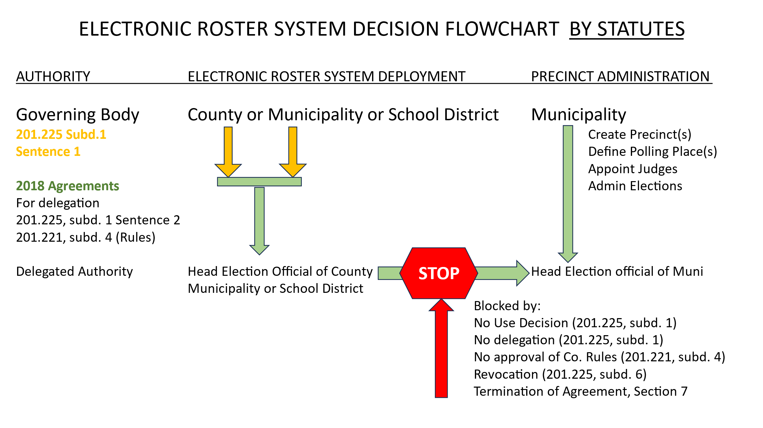

2. The graphic below illustrates the City of Oak Grove case in which the County did not vote for the 2018 agreement but the City of Oak Grove did.

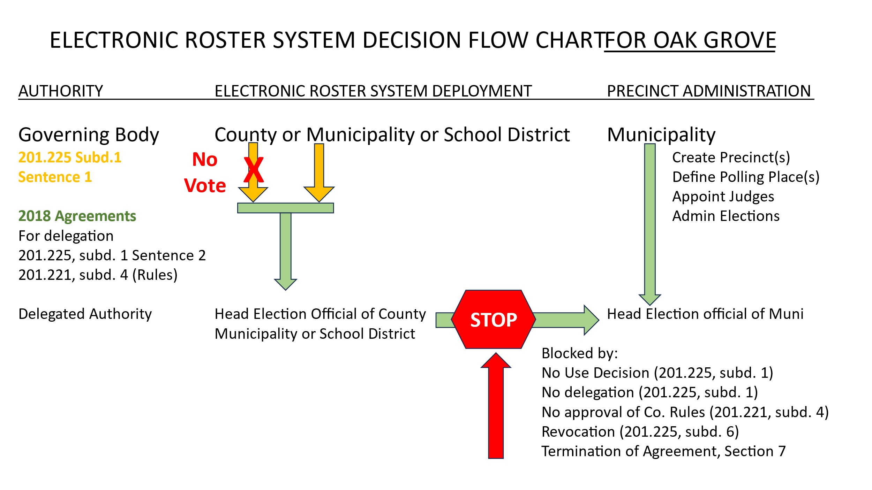

3. The graphic below illustrates the City of Ramsey (and apparently 19 other Anoka County municipalities) case in which neither the governing bodies of Anoka County nor of City of Ramsey formally voted to approve the 2018 Agreement.

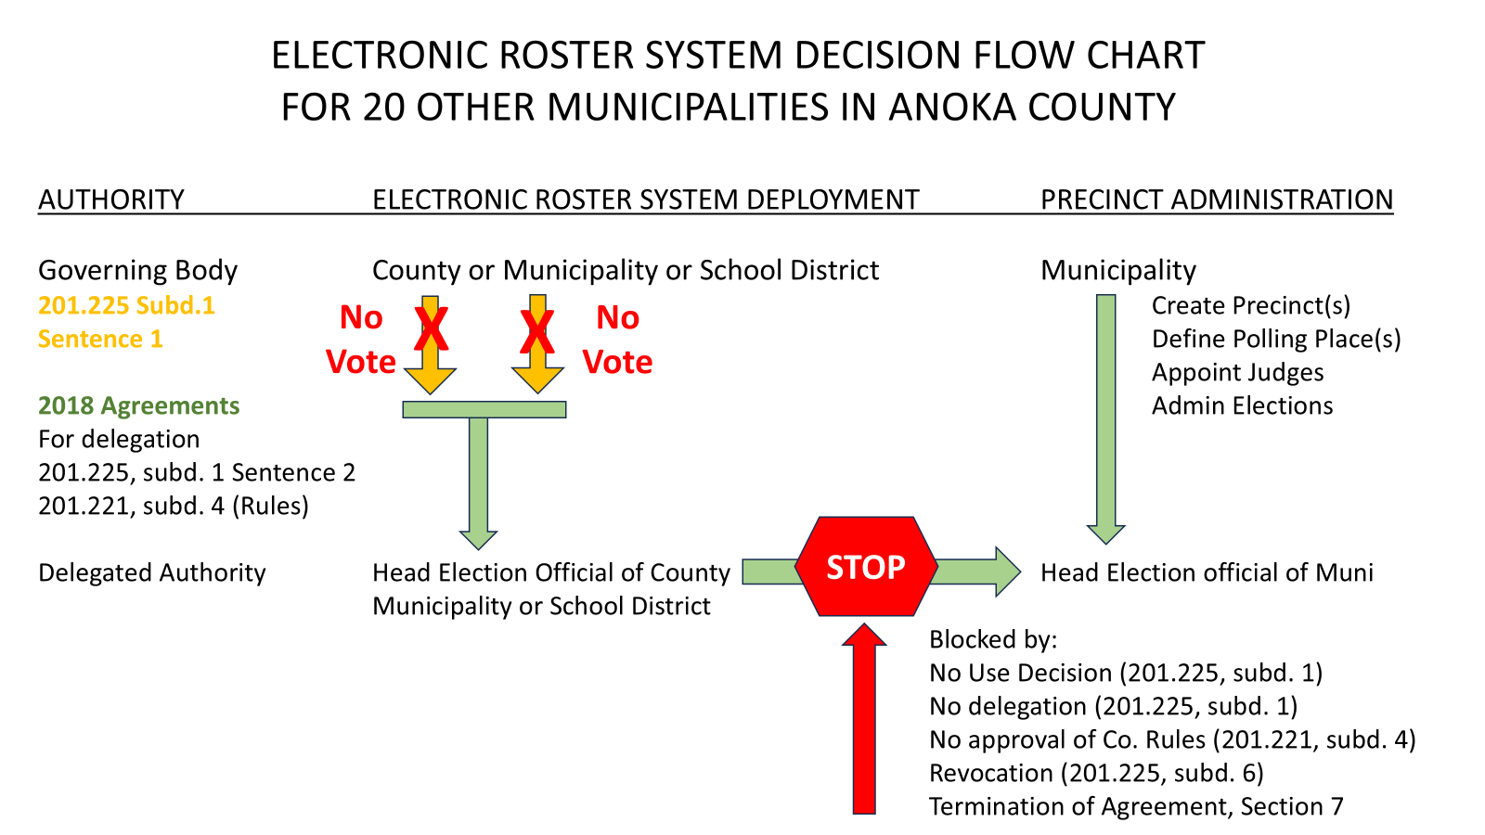

**IV. CONCLUSION**

Q1. Do Minnesota county auditors have the statutory authority to mandate use of electronic roster systems (aka electronic pollbooks or poll pads) in any or all precincts within their county without the approval of the governing bodies of the municipalities (cities and townships) involved?

A1. No. Minnesota county auditors must promulgate rules for deployment and use of electronic roster systems in any or all precincts within their county and said rules must be authorized by the governing bodies of the municipalities involved (201.221, subd. 4).

Q2. May municipalities independently decide if they will use electronic rosters (aka epollbooks or poll pads) in any or all of their precincts?

A2. Yes. Municipalities may decide if they will use electronic roster systems (poll pads) based upon statutory provisions that require municipal approval of county rules (201.221, subd. 4), municipal option to revoke precincts designated for poll pad use (201.225, subd. 6), and, in the case of Anoka County, the municipal option to terminate the 2018 agreements (Section 7).

Furthermore, the discharge of statutory duties and exercise of any statutory discretionary authority of county auditor is born by the Anoka County Board of Commissioners and then may be delegated to an appointed official within their organization delegation (383E.04).

Q3. Does the Anoka County Board need to approve delegation of functions to County Auditor (head election official)?

A3. Yes, as per MS 383E.04 (See Organization Chart-EXHIBIT T)

Q4. May the governing body of a municipality terminate the deployment and use of electronic roster system in their precincts?

A4. Yes, 201.225, subd. 6.

**V. EXHIBITS**

**A. Minnesota State Statutes**

1. 201.018 (making county auditor chief registrar of voters)

[Sec. 201.018 MN Statutes](https://www.revisor.mn.gov/statutes/cite/201.018)

**201.018 REGISTRATION FOR VOTING.**

Subdivision 1. [Repealed, [1984 c 560 s 26](https://www.revisor.mn.gov/laws/1984/0/560/#laws.0.26.0)]

Subd. 2.**Registration required.**

An eligible voter must register in a manner specified by section [201.054](https://www.revisor.mn.gov/statutes/cite/201.054), in order to vote in any primary, special primary, general, school district, or special election held in the county.

2. 201.221 (enabling rules for chapter 201-Eligibility and Registration of Voters)

1. Subd. 4 (county rules require municipal governing body approval)

[Sec. 201.221 MN Statutes](https://www.revisor.mn.gov/statutes/cite/201.221)

**201.221 RULES.**

Subdivision 1. **Adoption of rules.** To implement the provisions of this chapter, the secretary of state shall adopt rules consistent with federal and state election laws.

Subd. 2.**Uniform procedures for counties.** The secretary of state shall assist local election officers by devising uniform forms and procedures. The secretary of state shall provide uniform rules for maintaining voter registration records on the statewide registration system. The secretary of state shall supervise the development and use of the statewide registration system to insure that it conforms to applicable federal and state laws and rules.

Subd. 3.**Procedures for polling place rosters.** The secretary of state shall prescribe the form of paper polling place rosters that include the voter's name, address, date of birth, school district number, and space for the voter's signature. An electronic roster and the voter signature certificate together must include the same information as a paper polling place roster. The secretary of state may prescribe additional election-related information to be placed on the polling place rosters on an experimental basis for one state primary and general election cycle; the same information may not be placed on the polling place roster for a second state primary and general election cycle unless specified in this subdivision. The polling place roster must be used to indicate whether the voter has voted in a given election. The secretary of state shall prescribe procedures for transporting the polling place rosters to the election judges for use on election day. The secretary of state shall prescribe the form for a county or municipality to request the date of birth from currently registered voters. The county or municipality shall not request the date of birth from currently registered voters by any communication other than the prescribed form and the form must clearly indicate that a currently registered voter does not lose registration status by failing to provide the date of birth. In accordance with section [204B.40](https://www.revisor.mn.gov/statutes/cite/204B.40), the county auditor shall retain the prescribed polling place rosters used on the date of election for 22 months following the election.

Subd. 4.**County rules.** The county auditor of each county may adopt rules that delegate to the secretary of state or municipal officials in that county the duties assigned to county auditors by this chapter. Delegation of duties to the secretary of state requires the approval of the secretary of state. Delegation to a municipal official requires the approval of the governing body of the municipality. Delegation by the county auditor of the duty to accept registrations does not relieve the county auditor of the duty to accept registrations. Each delegation agreement must include a plan to allocate the costs of the duties to be delegated.

**History:**

[*1973 c 676 s 17*](https://www.revisor.mn.gov/laws/1973/0/676/#laws.0.17.0)*;*[*1978 c 714 s 30*](https://www.revisor.mn.gov/laws/1978/0/714/#laws.0.30.0)*;*[*1981 c 29 art 2 s 24*](https://www.revisor.mn.gov/laws/1981/0/29/#laws.2.24.0)*;*[*1981 c 92 s 2*](https://www.revisor.mn.gov/laws/1981/0/92/#laws.0.2.0)*;*[*1986 c 444*](https://www.revisor.mn.gov/laws/1986/0/444/#laws.0.0.0)*;*[*1987 c 266 art 1 s 10*](https://www.revisor.mn.gov/laws/1987/0/266/#laws.1.10.0)*;*[*1987 c 361 s 13*](https://www.revisor.mn.gov/laws/1987/0/361/#laws.0.13.0)*,14;*[*1990 c 585 s 16*](https://www.revisor.mn.gov/laws/1990/0/585/#laws.0.16.0)*;*[*2004 c 293 art 1 s 19*](https://www.revisor.mn.gov/laws/2004/0/293/#laws.1.19.0)*,20;*[*2014 c 288 art 2 s 3*](https://www.revisor.mn.gov/laws/2014/0/288/#laws.2.3.0)

3. 201.225 (enabling decision to use electronic roster system—poll pads)

[Sec. 201.225 MN Statutes](https://www.revisor.mn.gov/statutes/cite/201.225)

1. Subd. 1 (delegation of authority to head election judge)
2. Subd. 6 (reporting including municipal/school district revocation)

**201.225 ELECTRONIC ROSTER AUTHORIZATION.**

Subdivision 1. **Authority.** A county, municipality, or school district may use electronic rosters for any election. In a county, municipality, or school district that uses electronic rosters, the head elections official may designate that some or all of the precincts use electronic rosters. An electronic roster must comply with all of the requirements of this section. An electronic roster must include information required in section [201.221](https://www.revisor.mn.gov/statutes/cite/201.221), subdivision 3, and any rules adopted pursuant to that section.

Subd. 2.**Technology requirements.** An electronic roster must:

(1) be able to be loaded with a data file that includes voter registration data in a file format prescribed by the secretary of state;

(2) allow for data to be exported in a file format prescribed by the secretary of state;

(3) allow for data to be entered manually or by scanning a Minnesota driver's license or identification card to locate a voter record or populate a voter registration application that would be printed and signed and dated by the voter. The printed registration application can be a printed form, a label printed with voter information to be affixed to a preprinted form, a combination of a form and label, or an electronic record that the voter signs electronically and is printed following its completion at the polling place;

(4) allow an election judge to update data that was populated from a scanned driver's license or identification card;

(5) cue an election judge to ask for and input data that is not populated from a scanned driver's license or identification card that is otherwise required to be collected from the voter or an election judge;

(6) immediately alert the election judge if the voter has provided information that indicates that the voter is not eligible to vote;

(7) immediately alert the election judge if the electronic roster indicates that a voter has already voted in that precinct, the voter's registration status is challenged, or it appears the voter maintains residence in a different precinct;

(8) provide immediate instructions on how to resolve a particular type of challenge when a voter's record is challenged;

(9) provide for a printed voter signature certificate, containing the voter's name, address of residence, date of birth, voter identification number, the oath required by section [204C.10](https://www.revisor.mn.gov/statutes/cite/204C.10), and a space for the voter's original signature. The printed voter signature certificate can be a printed form, a label printed with the voter's information to be affixed to the oath, or an electronic record that the voter signs electronically and is printed following its completion at the polling place;

(10) contain only preregistered voters within the precinct, and not contain preregistered voter data on voters registered outside of the precinct, unless being utilized for absentee or early voting under chapter 203B or for mail balloting on election day pursuant to section [204B.45, subdivision 2a](https://www.revisor.mn.gov/statutes/cite/204B.45#stat.204B.45.2a);

(11) be only networked within the polling location on election day, except for the purpose of updating absentee ballot records;

(12) meet minimum security, reliability, and networking standards established by the Office of the Secretary of State in consultation with the Department of Information Technology Services;

(13) be capable of providing a voter's correct polling place; and

(14) perform any other functions necessary for the efficient and secure administration of the participating election, as determined by the secretary of state.

Electronic rosters used only for election day registration do not need to comply with clauses (1), (8), and (10). Electronic rosters used only for preregistered voter processing do not need to comply with clauses (4) and (5).

Subd. 3.**Minnesota Election Law; other law.** Unless otherwise provided, the provisions of the Minnesota Election Law apply to the use of electronic rosters. Voters participating in the safe at home program must be allowed to vote pursuant to section [5B.06](https://www.revisor.mn.gov/statutes/cite/5B.06). Nothing in this section shall be construed to amend absentee voting provisions in chapter 203B.

Subd. 4.**Election records retention.** All voter signature certificates and voter

registration applications printed from an electronic roster must be retained

pursuant to section [204B.40](https://www.revisor.mn.gov/statutes/cite/204B.40). The electronic rosters must print voter

signature certificates and voter registration applications on material that will

remain legible through the period prescribed by section [204B.40](https://www.revisor.mn.gov/statutes/cite/204B.40). Data on

election day registrants and voter history must be uploaded to the statewide

voter registration system for processing by county auditors.

Subd. 5.**Election day.** (a) Precincts may use electronic rosters for election day registration, to process preregistered voters, or both. The printed election day registration applications must be reviewed when electronic records are processed in the statewide voter registration system. The election judges shall determine the number of ballots to be counted by counting the number of original voter signature certificates or the number of voter receipts.

(b) Each precinct using electronic rosters shall have a paper backup system approved by the secretary of state present at the polling place to use in the event that the election judges are unable to use the electronic roster.

Subd. 6.**Reporting; certification.** (a) A county, municipality, or school district that intends to use electronic rosters in an upcoming election must notify the Office of the Secretary of State at least 90 days before the first election in which the county, municipality, or school district intends to use electronic rosters. The notification must specify whether all precincts will use electronic rosters, and if not, specify which precincts will be using electronic rosters. The notification is valid for all subsequent elections, unless revoked by the county, municipality, or school district. If precincts within a county, municipality, or school district that were not included in the initial notification intend to use electronic rosters, a new notification must be submitted.

(b) The county, municipality, or school district that intends to use electronic rosters must certify to the Office of the Secretary of State at least 30 days before the election that the electronic rosters meet all of the requirements in this section.

**History:**

[*2014 c 288 art 1 s 1*](https://www.revisor.mn.gov/laws/2014/0/288/#laws.1.1.0)*;*[*2016 c 158 art 1 s 78*](https://www.revisor.mn.gov/laws/2016/0/158/#laws.1.78.0)*;*[*2021 c 31 art 2 s 16*](https://www.revisor.mn.gov/laws/2021/0/31/#laws.2.16.0)*;*[*2023 c 62 art 4 s 26*](https://www.revisor.mn.gov/laws/2023/0/62/#laws.4.26.0)

4. 204B (municipal authority over precincts)

[Sec. 204B.14 MN Statutes](https://www.revisor.mn.gov/statutes/cite/204B.14)

a. Section 14, Subd. 1 (establish & manage boundaries)

Subdivision 1. **Boundaries.** The governing body of each municipality shall establish the boundaries of the election precincts in the municipality. The governing body of a county shall establish the boundaries of precincts in unorganized territory in the county. Except as provided in subdivision 3, a governing body may change the boundaries of any election precinct which it has established.

1. Section 16, subd. 1 (designate and manage polling places)

[Sec. 204B.16 MN Statutes](https://www.revisor.mn.gov/statutes/cite/204B.16)

Subdivision 1. **Authority; location**. (a) By December 31 of each year, the governing body of each municipality and of each county with precincts in unorganized territory must designate by ordinance or resolution any changes to a polling place location.

c. Section 21, subd. 2 (appoint and supervise election judges)

[Sec. 204B.21 MN Statutes](https://www.revisor.mn.gov/statutes/cite/204B.21)

Subd. 2. **Appointing authority; powers and duties.** Election judges for precincts in a municipality shall be appointed by the governing body of the municipality.

d. 204B.27, subd. 5 (making county auditor responsible for training local officers/judges)

[Sec. 204B.27 MN Statutes](https://www.revisor.mn.gov/statutes/cite/204B.27)

Subd. 5. **Conferences for county auditors.** Before each state primary the secretary of state shall conduct conferences with county auditors to instruct them on the administration of election laws and the training of local election officials and election judges.

5. 204D.11 (making county auditor in charge of state general election ballot)

[Sec. 204D.11 MN Statutes](https://www.revisor.mn.gov/statutes/cite/204D.11)

**204D.11 STATE GENERAL ELECTION BALLOTS; CANDIDATES; OFFICIAL IN CHARGE; RULES.**

Subdivision 1. **State general election ballot; rules.** The names of the candidates for all state and federal offices, all proposed constitutional amendments, all county offices and questions, and all judicial offices voted on at the state general election shall be placed on a single ballot that shall be known as the "state general election ballot." This ballot shall be prepared by the county auditor subject to the rules of the secretary of state. The secretary of state shall adopt rules for preparation and time of delivery of the state general election ballot.

Subd. 2. [Repealed, [2013 c 131 art 2 s 85](https://www.revisor.mn.gov/laws/2013/0/131/#laws.2.85.0)]

Subd. 3. [Repealed, [2013 c 131 art 2 s 85](https://www.revisor.mn.gov/laws/2013/0/131/#laws.2.85.0)]

Subd. 4. **Special federal ballot.** (a) The names of all candidates for the offices of president and vice-president of the United States and senator and representative in Congress shall be placed on a ballot that shall be known as the "special federal ballot."

(b) This ballot shall be prepared by the county auditor in the same manner as the state general election ballot and shall be subject to the rules adopted by the secretary of state pursuant to subdivision 1. This ballot must be prepared and furnished in accordance with the federal Uniformed and Overseas Citizens Absentee Voting Act, United States Code, title 52, sections 20301 to 20310.

(c) The special federal ballot shall be the only ballot sent to citizens of the United States who are eligible to vote by absentee ballot for federal candidates in Minnesota.

Subd. 5. **Ballot headings.** The ballot containing the offices and questions in subdivisions 1 and 4 shall be headed with the words "State General Election Ballot."

Subd. 6. **Judicial ballot.** When it would not be possible to place all offices on a single ballot card for the state general election, the judicial offices may be placed instead on a separate judicial ballot. The judicial ballot shall be prepared by the county auditor in the manner provided in the rules of the secretary of state.

The judicial ballot must be headed with the words: "Judicial Nonpartisan General Election Ballot." Separate ballot boxes must be provided for these judicial ballots.

**History:**

[*1981 c 29 art 6 s 11*](https://www.revisor.mn.gov/laws/1981/0/29/#laws.6.11.0)*;*[*1983 c 216 art 2 s 26*](https://www.revisor.mn.gov/laws/1983/0/216/#laws.2.26.0)*;*[*1983 c 247 s 90*](https://www.revisor.mn.gov/laws/1983/0/247/#laws.0.90.0)*;*[*1983 c 301 s 163*](https://www.revisor.mn.gov/laws/1983/0/301/#laws.0.163.0)*;*[*1983 c 303 s 17*](https://www.revisor.mn.gov/laws/1983/0/303/#laws.0.17.0)*,18;*[*1984 c 560 s 18*](https://www.revisor.mn.gov/laws/1984/0/560/#laws.0.18.0)*-21;*[*1986 c 444*](https://www.revisor.mn.gov/laws/1986/0/444/#laws.0.0.0)*;*[*1986 c 475 s 16*](https://www.revisor.mn.gov/laws/1986/0/475/#laws.0.16.0)*-18;*[*1987 c 175 s 12*](https://www.revisor.mn.gov/laws/1987/0/175/#laws.0.12.0)*;*[*1992 c 513 art 3 s 44*](https://www.revisor.mn.gov/laws/1992/0/513/#laws.3.44.0)*,45;*[*1993 c 223 s 16*](https://www.revisor.mn.gov/laws/1993/0/223/#laws.0.16.0)*-18;*[*1999 c 132 s 27*](https://www.revisor.mn.gov/laws/1999/0/132/#laws.0.27.0)*;*[*1Sp2001 c 10 art 18 s 33*](https://www.revisor.mn.gov/laws/2001/1/10/#laws.18.33.0)*;*[*2013 c 131 art 2 s 42*](https://www.revisor.mn.gov/laws/2013/0/131/#laws.2.42.0)*-45;*[*2015 c 70 art 1 s 47*](https://www.revisor.mn.gov/laws/2015/0/70/#laws.1.47.0)

6. 205 (municipal authority over non-state elections)

[Ch. 205 MN Statutes](https://www.revisor.mn.gov/statutes/cite/205)

7. 205A (school districts authority over non-state elections)

[Ch. 205A MN Statutes](https://www.revisor.mn.gov/statutes/cite/205A)

8. 383E.03-04 (Anoka County change auditor from elected to appointed)

[Sec. 383E.03 MN Statutes](https://www.revisor.mn.gov/statutes/cite/383E.03)

[Sec. 383E.04 MN Statutes](https://www.revisor.mn.gov/statutes/cite/383E.04)

**383E.03 APPOINTMENT OF COUNTY OFFICIALS.**

Upon adoption of a resolution by the Anoka County Board of Commissioners, the offices of county auditor, county recorder, and county treasurer in the county shall not be elective but shall be filled by appointment by the county board as provided in sections 383E.03 to 383E.06, unless the office is abolished pursuant to a reorganization or consolidation under section 383E.04.

**History:**

[*1989 c 243 s 1*](https://www.revisor.mn.gov/laws/1989/0/243/#laws.0.1.0)*;*[*2005 c 28 s 1*](https://www.revisor.mn.gov/laws/2005/0/28/#laws.0.1.0)

**383E.04 REORGANIZATION OF COUNTY OFFICES.**

(a) Upon adoption of a resolution by the Anoka County Board of Commissioners and subject to sections 383E.05 and 383E.06, the duties of the elected officials required by statute whose offices are made appointive by sections 383E.03 to 383E.06 shall be discharged by the board of commissioners of Anoka County acting through a department head or heads appointed by the board for that purpose. Each appointed department head shall serve at the pleasure of the board. The board may reorganize, consolidate, reallocate, or delegate the duties to promote efficiency in county government. It may make other administrative changes, including abolishing the offices of auditor, recorder, and treasurer. A reorganization, reallocation, or delegation or other administrative change or transfer shall not diminish, prohibit, or avoid the discharge of duties required by statute.

(b) The time requirements in sections 386.30 and 507.093 apply to an appointed department head described in paragraph (a) and begin after the tax certifications required by chapters 272 and 287 are made, but the total period to complete the time requirements after receipt of the instrument by the appointed department head must not exceed 60 days.

**History:**

[*1989 c 243 s 2*](https://www.revisor.mn.gov/laws/1989/0/243/#laws.0.2.0)*;*[*2000 c 275 s 3*](https://www.revisor.mn.gov/laws/2000/0/275/#laws.0.3.0)*;*[*2005 c 28 s 1*](https://www.revisor.mn.gov/laws/2005/0/28/#laws.0.1.0)

**B.** *2016 Electronic Roster Guide* [2016 Electronic Roster Guide](https://www.sos.state.mn.us/media/1989/electronic-roster-guide.pdf)

**C**. July 17/27, 2017: PRT Meeting agenda, staff report on poll pad purchase minutes

**D**. October 16, 2017: PRT Meeting agenda, staff report on poll pad purchase grant

**E**. October 24, 2017: County Board agenda & minutes approving grant application

**F.** March 12, 2018: PRT Meeting agenda & staff report on poll pad purchase

**G**. March 27, 2018: ACB Meeting agenda & minutes on poll pad purchase

**H**. May 2, 2018: Anoka Co. informed MN SOS of intend to use KNOWiNK poll pads

**I**. June/July, 2018: Staff report & Oak Grove Agreement with County for poll pad use

**J**. Sept. 21/28, 2021: Discussion & approval of JPA for vote tabulation equipment use

**K.** Sept.30, 2024: Anoka Co. report to MN SOS poll pad use in 2024 General Election

**L**. September 30, 2024: Oak Grove termination of agreement for use of poll pads

**M**. Oct. 8, 2024: Tom Hunt letter to City of Oak Grove mandating use of epollbooks

**N**. Oct. 10, 2024: FOIA response from County—21 agreements, no County approvals

**O**. Oct. 17, 2024: Tom Hunt email showing no evidence of County approvals

**P**. Oct. 28, 2024 (ca.): Legal Memorandum from County to head election judges

**Q.** Nov. 3, 2024: Tom Hunt email to Joe Richardson regarding prosecution threat

**R.** Nov 12, 2024: City of Ramsey resolutions to terminate and use paper only

**S.** Nov 12, 2024: City of Ramsey Attorney written and verbal opinions

**T**. Anoka County Organizational Chart [POG-05-28-2024](https://www.anokacountymn.gov/DocumentCenter/View/35826/POG-05-28-2024), page 4. Also see: Minnesota County Offices: Combining or Making Appointed [County Offices: Combining or Making Appointed](https://www.house.mn.gov/hrd/pubs/cntyoff.pdf)

**U.** Map of use of electronic roster system in Minnesota: [Minnesota Secretary Of State - 2022 Election Statistics](https://www.sos.state.mn.us/elections-voting/election-results/2022/2022-general-election-results/2022-election-statistics/); click on *EPOLLBOOK USAGE*. Click on map for details.

**V.** Minnesota Electronic Roster Use Survey Data

**END OF LEGAL MEMORANDUM**